Done, Chris
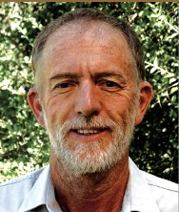
The TFS Sandalwood Project 2008 (TFS 2008) is the company’s twelfth Sandalwood Project under management. Expert Foresters to TFS, Peter Kimber and Chris Done, previously worked with the WA Department of Conservation and Land Management (CALM) on the original Sandalwood trial plantations in the area, and are widely renowned as Australia’s foremost Sandalwood experts. An experienced plantation management team is located in Kununurra to ensure your plantation is established and maintained to the highest order. The TFS parent company, TFS Corporation Ltd, listed on ASX Limited in December 2004. TFS first planted Indian Sandalwood in Kununurra in 1999 and has since planted over 1,200 hectares of commercial Sandalwood plantations on behalf of almost 700 individual growers and companies associated with TFS. TFS is a specialist Indian Sandalwood plantation manager and is committed to the long term development of an Australian grown Indian Sandalwood industry.
Graduated with BSc Forestry ANU in 1968. Worked for 7 years in Papua new Guinea forests. Back in Australia 1975. Joined W.A. Forests Department in 1976 as District Forests Officer in Nannup. Transferred to Kununurra as Regional Manager Kimberley in 1979. Retired 2003.

